1.

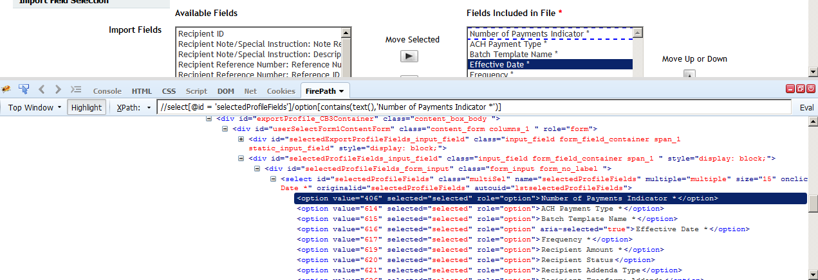

2. Why such complex xpath?

Because there are two “Import profile” options. One under Payments menu and another under Transfers menu. Both of them had very identical html properties.

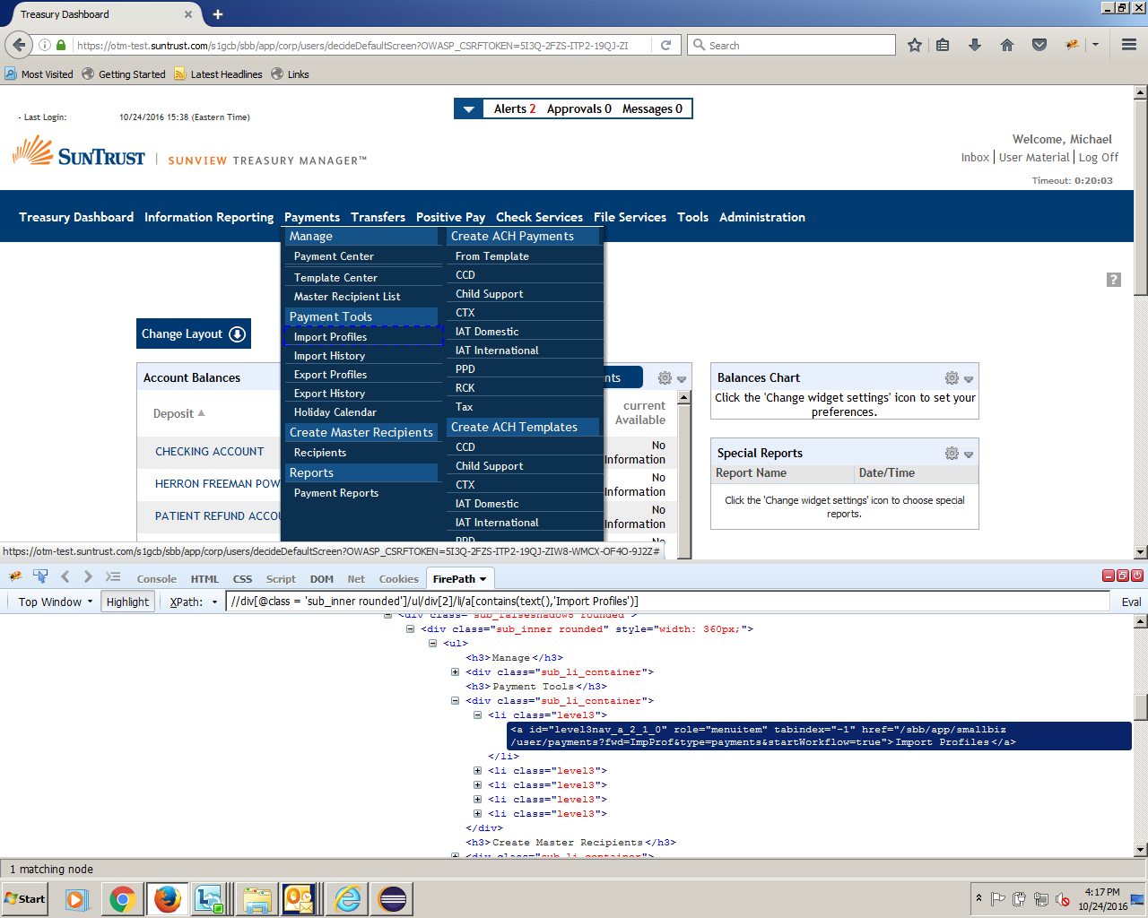

3. Node Contains exact Text.

In the below example, two profiles has “Test” word in it. Thus, “Contains” keyword will match both nodes. So I had to use the exact match option

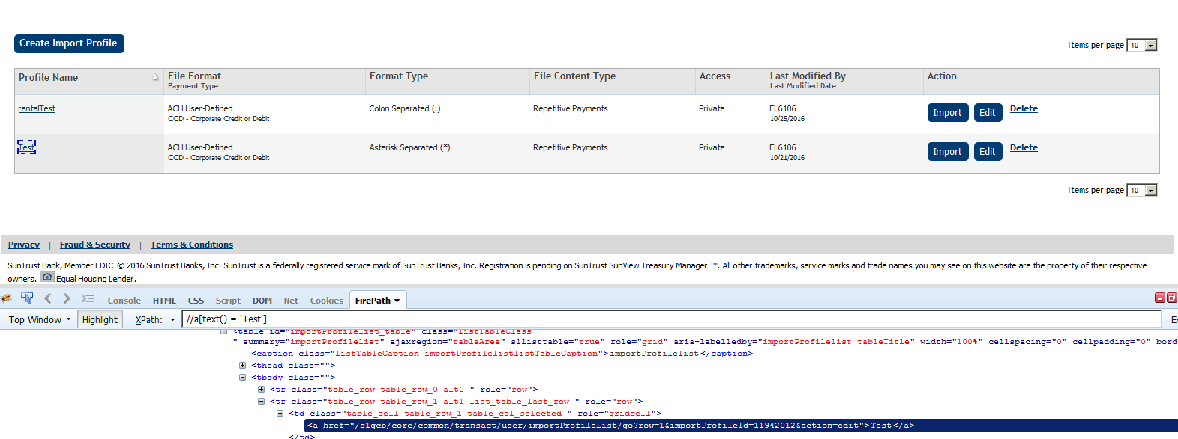

4. OR condition

The class value gets changed to “atoptabon” if the menu option is highlighted (Payments). Else, it will be “atoptab”. When we land up on this screen ,Which tab is on, cannot be predicted. Hence the OR condition in xpath

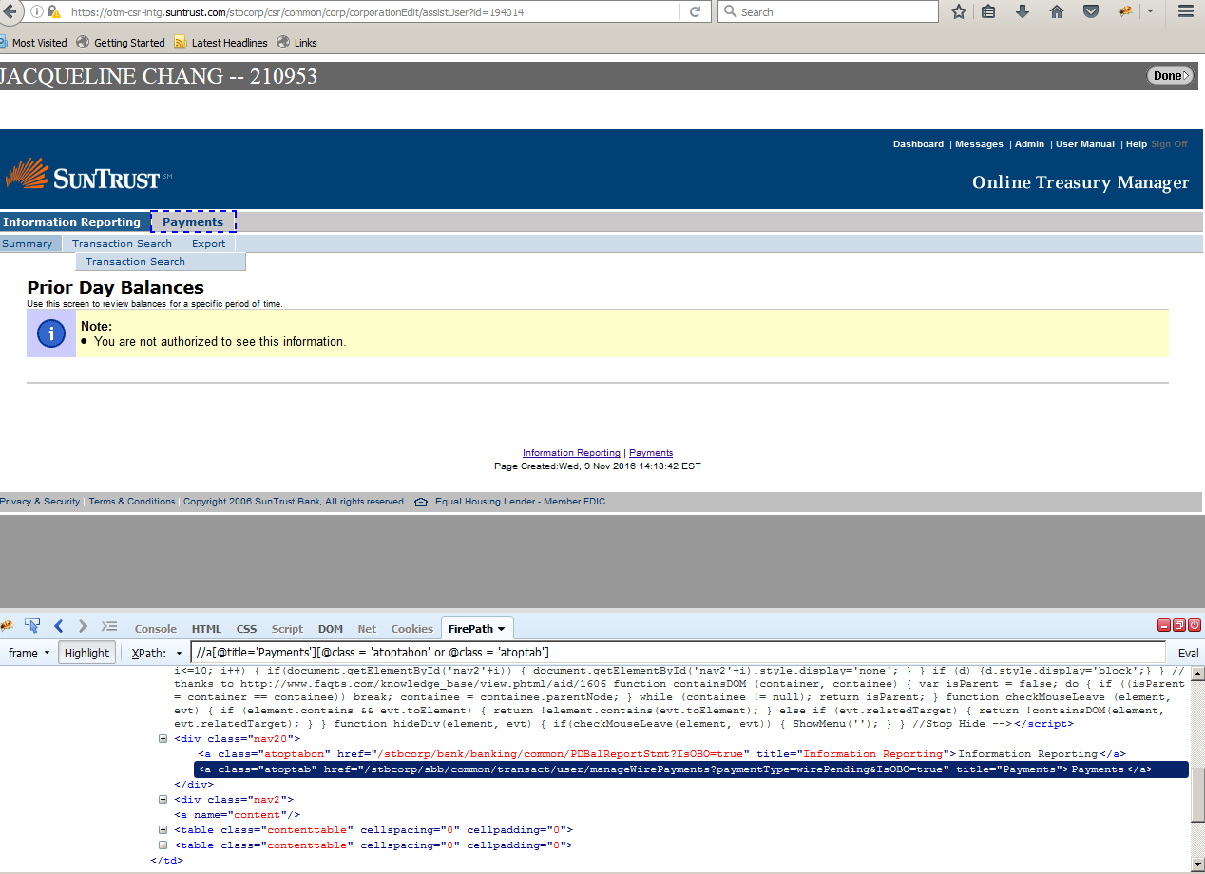

5. XPATH indexing

**Search** button’s html property (right from the beginning of the node of that section of page) is duplicated three times in the HTML page. So xpath was matching with 3 nodes. Reason: The search button was explicitly mentioned one each time for “pending”, “processed” and “All” Tab.

So I used index. At the end of xpath the number within the brackets will help to match the required node. In my case, number 3 helped me to catch the “Search” button in “All” tab.

